#CHECKING THE NULL & EMPTY VALUES
SELECT name FROM `baseball_data` WHERE name IS NULL && name="";
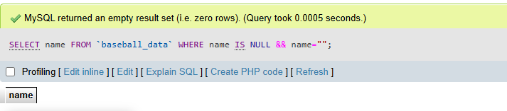
#DEFINE THE PLAYER HANDEDNESS TYPE
SELECT handedness, COUNT(handedness) AS count_handedness FROM `baseball_data` GROUP BY handedness;
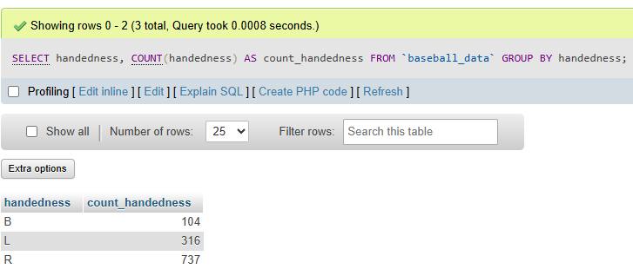
#TOP 6 NAME OF PLAYER BY MAX HEIGHT WISE
SELECT name, MAX(height) AS max_height FROM `baseball_data` GROUP BY name ORDER BY max_height DESC LIMIT 0, 6;
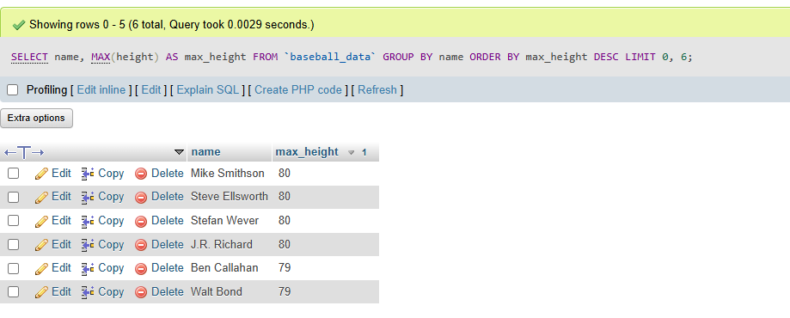

#TOP 6 NAME OF PLAYER BY MIN HEIGHT WISE
SELECT name, height AS min_height FROM `baseball_data` GROUP BY name ORDER BY min_height ASC LIMIT 0, 6;
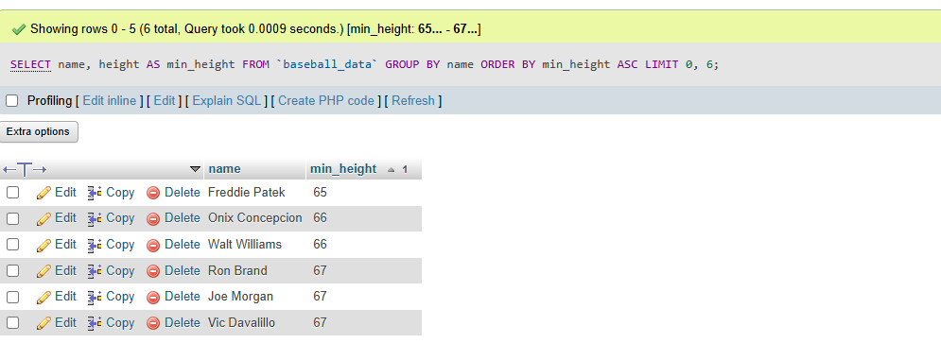
#TOP 6 NAME OF PLAYER BY MIN WEIGHT WISE
SELECT name, weight AS min_weight FROM `baseball_data` GROUP BY name ORDER BY min_weight ASC LIMIT 0, 6;
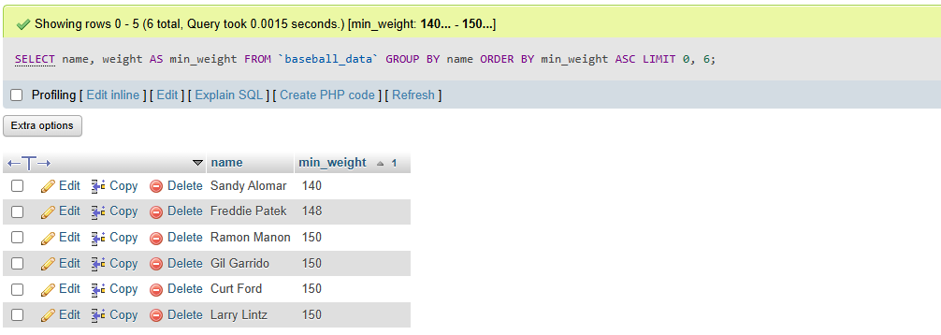
#TOP 6 NAME OF PLAYER BY MAX AVG WISE
SELECT name, avg AS max_avg FROM `baseball_data` GROUP BY name HAVING max_avg!=0.0 ORDER BY max_avg DESC LIMIT 0, 6;
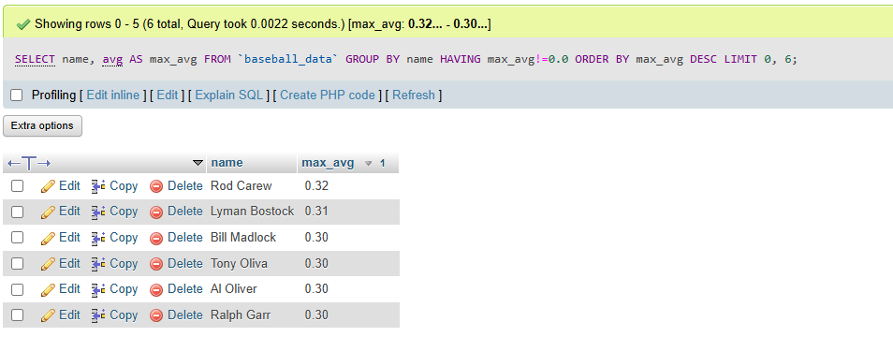
#TOP 6 NAME OF PLAYER BY MIN AVG WISE
SELECT name, avg AS min_avg FROM `baseball_data` GROUP BY name HAVING min_avg!=0.0 ORDER BY min_avg ASC LIMIT 0, 6;
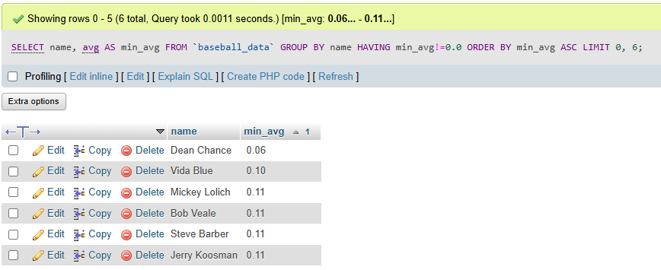

#TOP 6 NAME OF PLAYER BY MAX WEIGHT WISE
SELECT name, weight AS max_weight FROM `baseball_data` GROUP BY name ORDER BY max_weight DESC LIMIT 0, 6;
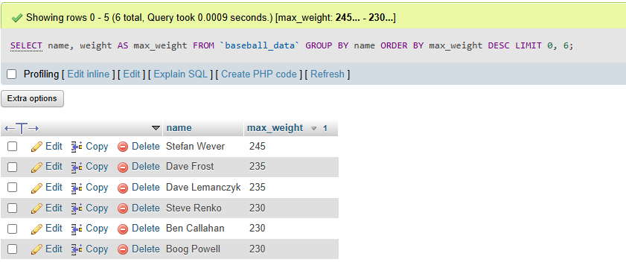

#TOP 8 NAME OF PLAYER BY MAX HR(Home Run) WISE
SELECT name, HR FROM `baseball_data` ORDER BY HR DESC LIMIT 0,8;
